FACULTY EVALUATION
Programme Name: Social Entrepreneurship Development Program (SEDP)- Advance Tanzania (2nd February - 6th February 2026)
Session: IT and Technology
Faculty Name: Kenneth Wakati
No. of Respondents: 23
No. of Participants: 23
Evaluation Parameter | (%) Individual Score | (%) Programme Average
Punctuality (Commencement and Completion of Sessions) | 92 | 95
How well do you understand the core concepts presented? | 82 | 90
Rate your confidence in applying the new skills learnt | 82 | 91
Degree of Faculty preparedness for the sessions | 87 | 94
Content and methodology of the program | 86 | 94
Quality of class and group discussions | 81 | 92
The information presented in the course is relevant to my work (ministry) | 87 | 94
Average scores | 85 | 93

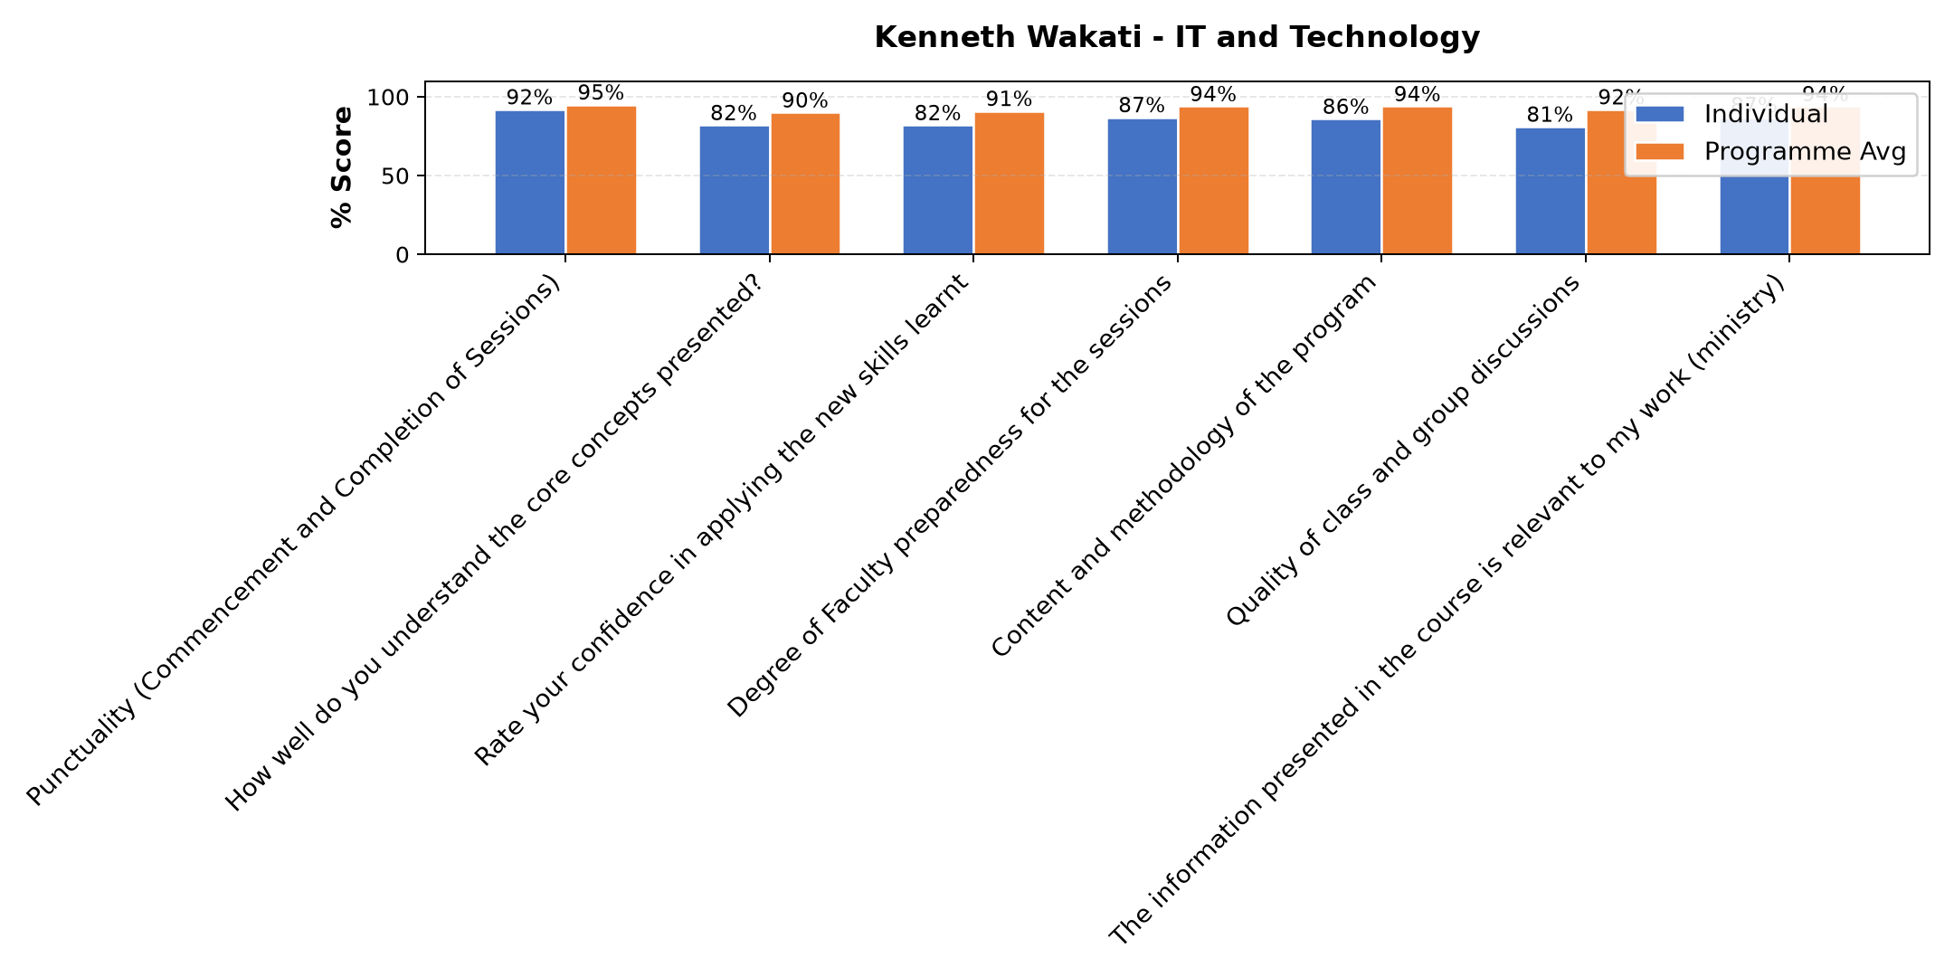

Comments & Feedback
- • Nimejifunza namna ya kutumia mtando na namna yakutangaza biashara yangu kwenye mtandao,pia ninavyo ingia kwenye mtando niwe makini na siyo kuogopa .
- • Not having modern tools like computer, phones, tablets etc
- • Lack of opportunities to apply the learning in real situation
- • Nothing
- • Ana uzofu wa kuwasilisha mada/ujumbe, somo lake lilieleweka kwa asilimia kubwa sana Wanafunzi waliweza kuingia kwa undani kwa njia ya kuuliza maswali.
- • Mwl amefundisha vyema kabisa
- • Nil
- • Just a phobia that am not safe
- • Ufahamu si mpana kwa baadhi ya program na matumizi yake
- • How to protect my ministry by creating strong password and verify information.
- • It might be indicators for technology hakers on that moment
- • Lack of enough knowledge about IT and new Technologies
SUBMITTED THROUGH:
SBS Evaluation Automation System

